

Practical No.: 6
Aim –
Use string functions and regex for email validation, data extraction, and text analysis.
Software/Tools Required –
VSCode, Chrome, HTML5, CSS3, Javascript (ES6)
Experiment Program Code –
index.html
<!DOCTYPE html>
<html>
<head>
<title>
String Methods and Regular Expressions
</title>

<style>
body {
font-family: Arial, sans-serif;
margin: 40px;
}

h1 {
text-align: center;
}

.box {
border: 1px solid #ccc;
padding: 20px;
margin-top: 20px;
border-radius: 8px;
}

input, textarea, button {
padding: 10px;
margin: 5px 0;
width: 90%;
}

button {
width: 150px;
cursor: pointer;
}

#output {
margin-top: 20px;
padding: 15px;
background-color: #f5f5f5;
}
</style>
</head>

<body>
<h1>String Methods & Regular Expressions</h1>
<div class="box">
<label><b>Enter a paragraph:</b></label> <br>

<textarea id="paragraph" rows="5" >Javascript is a powerful programming language. It is widely used for web development.
</textarea>
<br>

<label><b>Enter Email:</b></label> <br>
<input type="text" id="email" placeholder="Enter your email"> <br>

<button onclick="processString()">Process</button>
<div id="output"></div>
</div>

<script>
function processString() {
let paragraph = document.getElementById("paragraph").value;
let email = document.getElementById("email").value;

let words = paragraph.split(/\s+/);

let vowels = paragraph.match(/[aeiou]/gi);
let vowelCount = vowels ? vowels.length : 0;

let replacedParagraph = paragraph.replace(
/JavaScript/gi,
"JavaScript Programming"
);

let searchWord = "powerful";
let position = paragraph.indexOf(searchWord);

let emailRegex =
/^[a-zA-Z0-9._%+-]+@[a-zA-Z0-9.-]+\.[a-zA-Z]{2,}$/;

let emailResult;

if(emailRegex.test(email)) {
emailResult = "Valid Email Address";
} else {
emailResult = "Invalid Email Address";
}

let emailText =
"For queries contact student@example.com or admin@college.edu";

let extractedEmails = emailText.match(
/[a-zA-Z0-9._%+-]+@[a-zA-z0-9.-]+\.[a-zA-Z]{2,}/g
);

let reeversedParagraph = paragraph.split("").reverse().join("");

document.getElementById("output").innerHTML = `
<h3>1. Original Paragraph</h3>
<p>${paragraph}</p>

<h3>2. split() - Words</h3>
<p>${words.join(", ")} </p>

<h3>3. match() - Vowels</h3>
<p>${vowels ? vowels.join(", ") : "No vowels found"}</p>

<h3>4. Vowel Count</h3>
<p>Total number of vowels: <b>${vowelCount}</b></p>

<h3>5. replace() - Replaced Text</h3>
<p>${replacedParagraph}</p>

<h3>6. indexOf() - Search Word</h3>
<p> Position of "<b>${searchWord}</b>";
<b>${position}</b>
</p>

<h3>7. Email Validation Using Regex</h3>
<p>
Email: <b>${email}</b><br>
Result: <b>${emailResult}</b>
</p>

<h3>8. Regex - Extracted Information</h3>
<p>
${extractedEmails ? extractedEmails.join("<br>") : "No email address found"}
</p>

<h3>9. Revered Paragraph</h3>
<p>${reeversedParagraph}</p>
`;
}
</script>
</body>
</html>
Output –
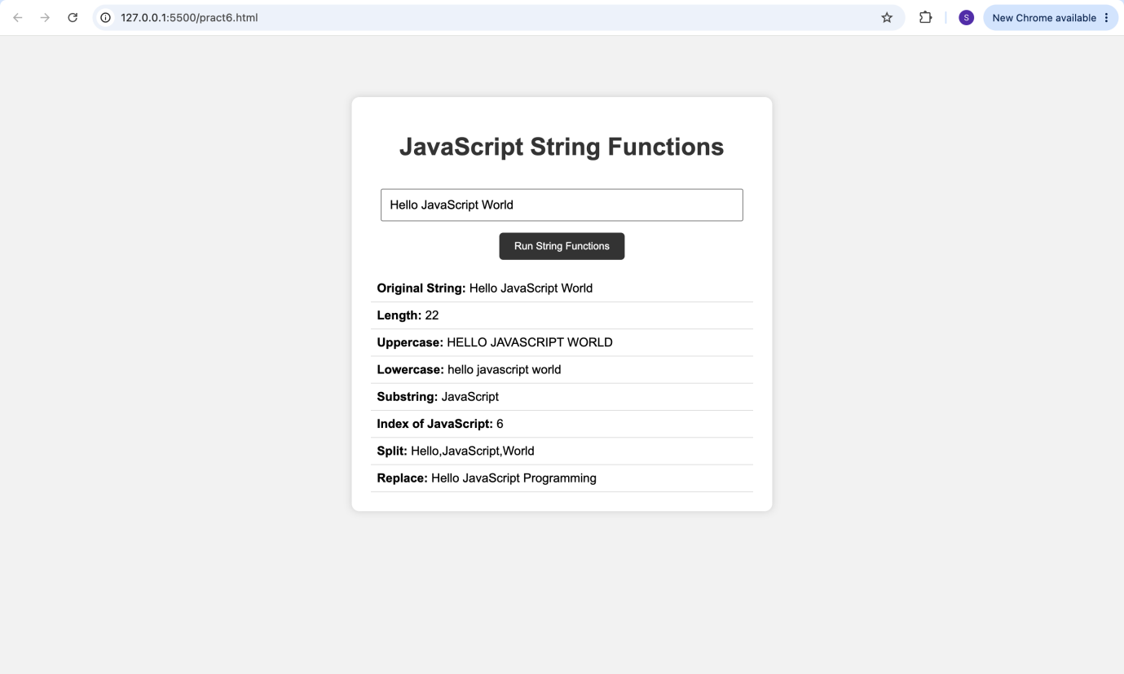

Case Study Title –
To reverse a string and count the number of vowels in a given string or paragraph.
Case Study Program Code –
index.html
<!DOCTYPE html>
<html>
<head>
<title>String Operations</title>
<link rel="stylesheet" href="style.css">
</head>

<body>

<div class="container">

<h1>String Operations</h1>

<div class="section">
<h2>Reverse a String</h2>

<input type="text" id="stringInput" placeholder="Enter a string">
<button onclick="reverseString()">Reverse</button>

<p id="reverseResult"></p>
</div>

<div class="section">
<h2>Count Vowels in a Paragraph</h2>

<textarea id="paragraphInput" placeholder="Enter a paragraph"></textarea>
<button onclick="countVowels()">Count Vowels</button>

<p id="vowelResult"></p>
</div>

</div>

<footer>
Designed by <strong>Rudrakshi Bhandekar</strong> |
PRN: <strong>24070521012</strong>
</footer>

<script src="script.js"></script>

</body>
</html>

style.css
* {
margin: 0;
padding: 0;
box-sizing: border-box;
}

body {
font-family: "Segoe UI", Arial, sans-serif;
min-height: 100vh;
margin: 0;
padding: 40px 20px;

background-image: url("background.webp");
background-size: cover;
background-position: center;
background-repeat: no-repeat;
background-attachment: fixed;

display: flex;
flex-direction: column;

color: #252b42;
}

.container {
width: 850px;
max-width: 90%;
margin: 0 auto 30px auto;
flex: 1;

background: rgba(255, 255, 255, 0.78);
padding: 40px;

border-radius: 24px;
border: 1px solid rgba(255, 255, 255, 0.8);

box-shadow: 0 20px 50px rgba(52, 72, 120, 0.18);

backdrop-filter: blur(12px);
}

h1 {
text-align: center;
font-size: 34px;
color: #252b42;
margin-bottom: 35px;
letter-spacing: 0.5px;
}

h1::after {
content: "";
display: block;

width: 70px;
height: 4px;

background: linear-gradient(90deg, #6c63ff, #4facfe);

border-radius: 10px;
margin: 12px auto 0;
}

.section {
background: rgba(255, 255, 255, 0.95);

padding: 28px;
margin-bottom: 24px;

border-radius: 18px;
border: 1px solid #e8eaf2;

box-shadow: 0 8px 25px rgba(45, 55, 90, 0.07);

transition: 0.3s ease;
}

.section:hover {
transform: translateY(-3px);

box-shadow: 0 12px 30px rgba(45, 55, 90, 0.13);
}

.section:last-child {
margin-bottom: 0;
}

h2 {
font-size: 21px;
color: #343b5c;
margin-bottom: 18px;
}

input,
textarea {
width: 100%;

padding: 14px 16px;
margin-bottom: 14px;

border: 1.5px solid #dfe2ec;
border-radius: 10px;

font-size: 15px;
font-family: inherit;

color: #333;
background: #fafbff;

outline: none;

transition: 0.3s ease;
}

input:focus,
textarea:focus {
border-color: #6c63ff;

background: white;

box-shadow: 0 0 0 4px rgba(108, 99, 255, 0.1);
}

input::placeholder,
textarea::placeholder {
color: #9aa0b5;
}

textarea {
height: 140px;
resize: vertical;
}

button {
padding: 12px 24px;

border: none;
border-radius: 10px;

background: linear-gradient(135deg, #6c63ff, #4facfe);

color: white;

font-size: 15px;
font-weight: 600;

cursor: pointer;

box-shadow: 0 6px 15px rgba(108, 99, 255, 0.25);

transition: 0.3s ease;
}

button:hover {
transform: translateY(-2px);

box-shadow: 0 9px 20px rgba(108, 99, 255, 0.35);
}

button:active {
transform: scale(0.97);
}

p {
margin-top: 18px;

padding: 13px 16px;

background: #f5f6ff;

border-left: 4px solid #6c63ff;

border-radius: 8px;

color: #343b5c;

font-size: 16px;
font-weight: 600;
}

footer {
width: 100%;

text-align: center;

padding: 16px 10px;

background: rgba(255, 255, 255, 0.65);

border-top: 1px solid rgba(255, 255, 255, 0.8);

backdrop-filter: blur(8px);

color: #382f35;

font-size: 20px;

letter-spacing: 0.3px;

margin-top: auto;
}

footer strong {
color: #a61739;
}

@media (max-width: 600px) {

body {
padding: 20px 12px;
}

.container {
max-width: 100%;
padding: 25px;

margin-bottom: 20px;
}

h1 {
font-size: 28px;
}

.section {
padding: 20px;
}

h2 {
font-size: 19px;
}

input,
textarea {
font-size: 14px;
}

button {
width: 100%;
}

footer {
font-size: 13px;
}
}
script.js
function reverseString() {
let str = document.getElementById("stringInput").value;

if (str.trim() === "") {
document.getElementById("reverseResult").innerHTML =
"Please enter a string.";
return;
}

let reversed = str.split("").reverse().join("");

document.getElementById("reverseResult").innerHTML =
"Reversed String: " + reversed;
}

function countVowels() {
let paragraph = document.getElementById("paragraphInput").value;

if (paragraph.trim() === "") {
document.getElementById("vowelResult").innerHTML =
"Please enter a paragraph.";
return;
}

let vowels = paragraph.match(/[aeiouAEIOU]/g);

let count = vowels ? vowels.length : 0;

document.getElementById("vowelResult").innerHTML =
"Number of Vowels: " + count;
}

Output –
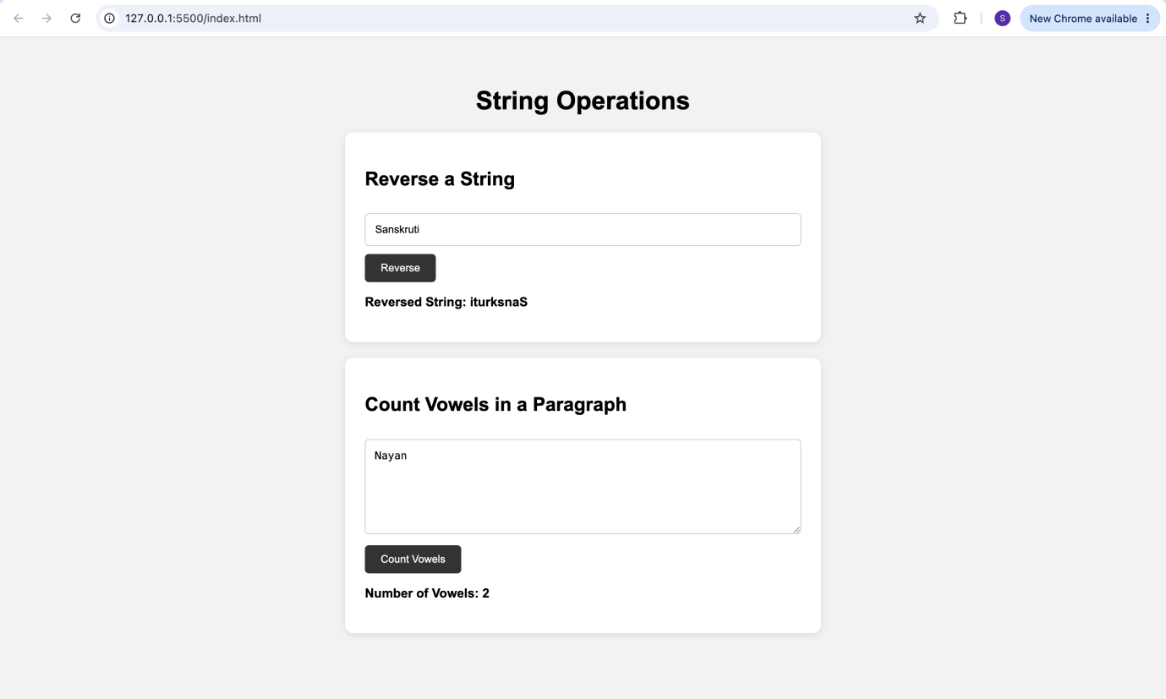
Conclusion –
The experiment was successfully performed to study various JavaScript string functions and regular expressions. Different string operations such as split(), match(), replace(), and indexOf() were used for text analysis. Regular expressions were also implemented for email validation and extraction of email addresses.
In the case study, a string was successfully reversed and the number of vowels and total characters were calculated. Thus, the practical helped in understanding string manipulation and the application of regular expressions in JavaScript.

